EXPT NO:6 | IMPLEMENTATION OF MULTIVARIATE DISPLAYS
DATE: 24.01.2026 | IMPLEMENTATION OF MULTIVARIATE DISPLAYS

PRE-LAB QUESTIONS
- Why are multivariate displays important in AI analytics?
Multivariate displays help analyze multiple variables at the same time, which is important in AI because models depend on many features together. They help in:
  - Finding hidden patterns and relationships
  - Detecting feature importance
  - Identifying outliers and anomalies
  - Understanding data distribution before training

- How do parallel coordinates differ from scatter plots?
  - Scatter Plot: compares only 2 variables at a time (X vs Y).
  - Parallel Coordinates: compares many variables together by drawing each record as a line across multiple axes.
Parallel coordinates are better when you want to see multi-feature behavior in one view.

- What challenges exist in interpreting multivariate plots? Some common challenges are:
  - Overplotting / clutter (too many lines or points)
  - Hard to track patterns when variables are many
  - Difficult to interpret without good scaling or normalization
  - Requires more skill to read compared to simple plots

- Where are trellis displays commonly used?
Trellis displays are used when we want to compare the same chart across categories, such as:
  - Sales performance by region
  - Customer behavior by segment
  - Machine sensor readings by machine type
  - Medical data by age group or gender
They are common in business analytics, healthcare, and ML feature analysis.

- How does multivariate visualization aid model evaluation? It helps evaluate AI models by:
  - Showing how features affect predictions
  - Identifying misclassified regions
  - Checking feature interactions that influence accuracy
  - Detecting bias across groups (region, segment, category)
  - Understanding errors and improving model performance

OBJECTIVE : To implement advanced multivariate displays for complex data analysis.

SCENARIO A retail analytics firm studies sales, profit, customer segment, and region to optimize business strategy.
IN-LAB TASKS (Using R Language) • Create parallel coordinate plots • Generate bubble charts • Implement trellis displays by region

CODE:

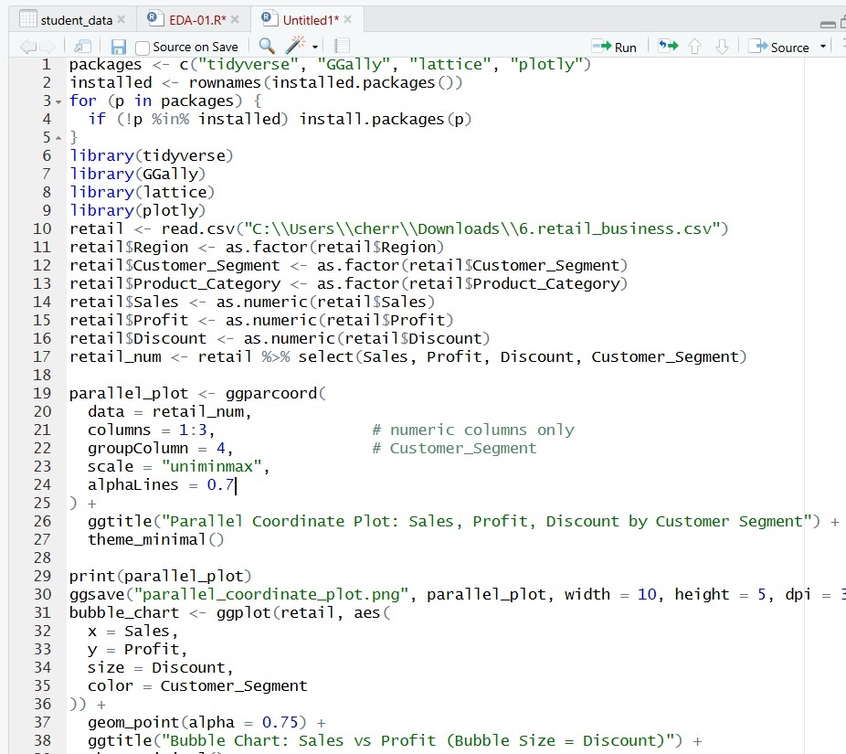

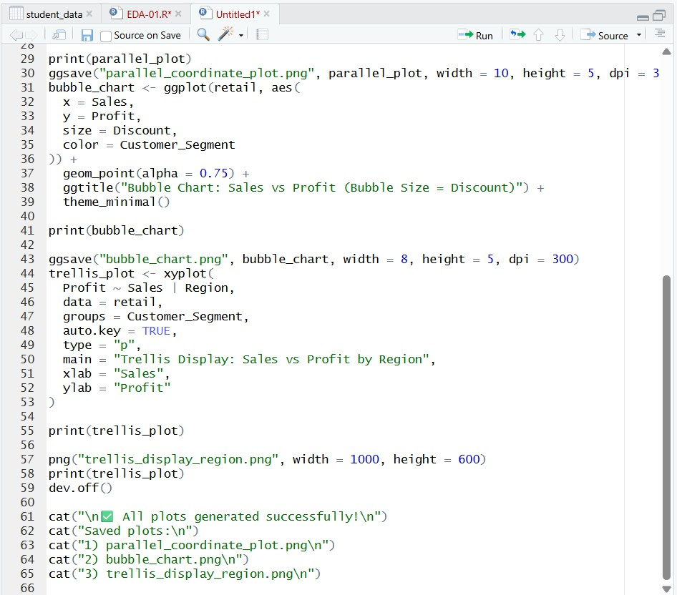
OUTPUT:
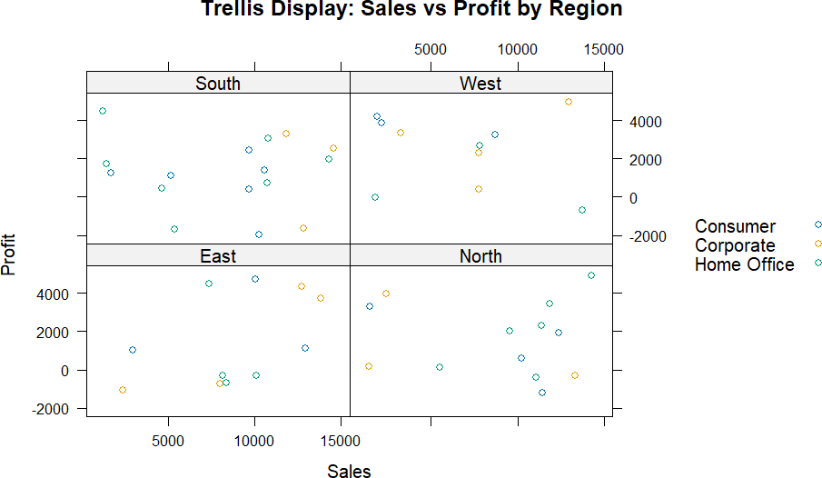

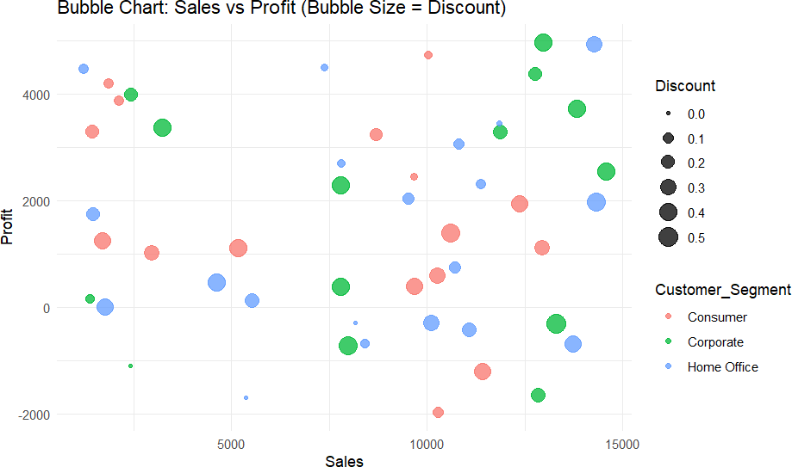

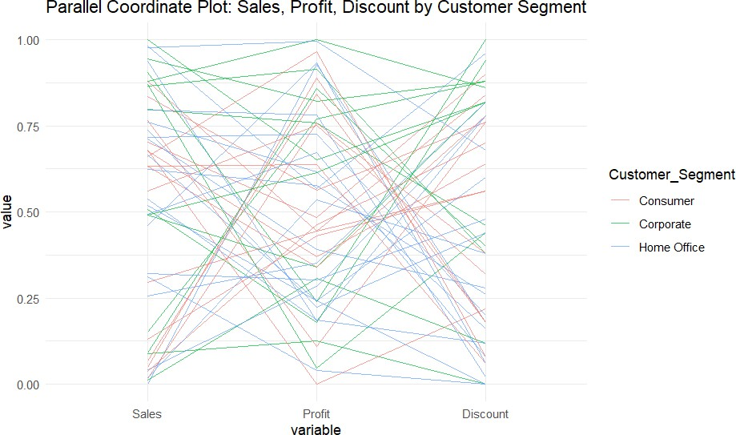

POST-LAB QUESTIONS

- What insights are gained from parallel coordinates? Parallel coordinate plots help identify:
  - Patterns across multiple variables at once
  - High/low performance trends (ex: high sales but low profit)
  - Clusters of similar records
  - Outliers where a line deviates strongly from others

- How does faceting simplify complex data?
Faceting splits one big plot into multiple smaller plots based on categories (like region/segment).
This makes it easier to:
  - Compare groups side-by-side
  - Detect category-wise differences clearly
  - Reduce clutter and improve readability

- What limitations exist in bubble charts? Bubble charts can be difficult because:
  - Too many bubbles cause overlapping
  - Bubble size differences are hard to judge accurately
  - Small bubbles may become invisible
  - Not ideal for very large datasets (becomes messy)

- How can these displays support AI-driven recommendations? These plots help AI systems by:
  - Finding which segments/regions give higher profit
  - Identifying products with high sales but low profit for improvement
  - Supporting personalized offers using customer segment behavior
  - Helping models recommend best strategies based on patterns in data

- Suggest improvements for large multivariate datasets. For large datasets, improve multivariate visualization by:
  - Using filtering and sampling to reduce clutter
  - Applying normalization/scaling for fair comparison
  - Using interactive dashboards (zoom, hover, highlight)
  - Using dimensionality reduction like PCA/t-SNE for better feature view
  - Grouping data using clustering before plotting

LEARNING OUTCOME: Students apply multivariate visualization for business intelligence.

ASSESSMENT

Description | Max Marks | Marks Awarded
Pre Lab Exercise | 5
In Lab Exercise | 10
Post Lab Exercise | 5
Viva | 10
Total | 30
Faculty Signature

